Software Requirements Specification

for

Student Registration System

Version 1.0 approved

Prepared by Rafat Munshi

Aug 20, 2016

Table of Contents

Table of Contents ii

Revision History ii

1. Introduction 1

1.1 Purpose 1

1.2 Intended Audience and Reading Suggestions 1

1.3 Product Scope 1

1.4 References 2

2. Overall Description 2

2.1 Product Perspective 2

2.2 Product Functions 3

2.4 Operating Environment 3

2.5 Design and Implementation Constraints 4

3. External Interface Requirements 4

3.1 User Interfaces 4

3.2 Hardware Interfaces 13

3.3 Software Interfaces 13

4. System Features 13

4.1 Functional Requirement Specification 14

4.2 User characteristics 15

4.2 Forgot password feature 16

5. Other Nonfunctional Requirements 16

5.1 Logical structure of the data 16

Revision History

|  |  |  |  |
| --- | --- | --- | --- |
| **Name** | **Date** | **Reason For Changes** | **Version** |
|  |  |  |  |
|  |  |  |  |

# Introduction

## Purpose

The purpose of this document is to present a detailed description of the Student Registration System. It will explain the purpose and features of the system, the interfaces of the system, what the system will do, the constraints under which it must operate and how the system will react to external stimuli. This document is intended for both the stakeholders and the developers of the system

## Intended Audience and Reading Suggestions

This document is intended for the developers, users, testers, and documentation writers.

## Product Scope

This web based application system will be a Student Registration System for a a student of the university as well as the administrator of the application. This system will be designed to register students for the particular semesters in the various courses offered by the University. It shall provide a one stop place for students to register, view and edit their details as well as the admin for viewing all students in the course and edit student and course information, which would have been much difficult with paper work and files. By maximizing the student’s and admin’s work efficiency, the system will meet the university’s needs and requirements while remaining easy to understand and use.

The system also contains a relational database containing a list of courses with their maximum limit, All student details, and hostel details.

## References

IEEE. *IEEE Std 830-1998 IEEE Recommended Practice for Software Requirements Specifications.* IEEE Computer Society, 1998.

# Overall Description

## 2.1 Product perspective

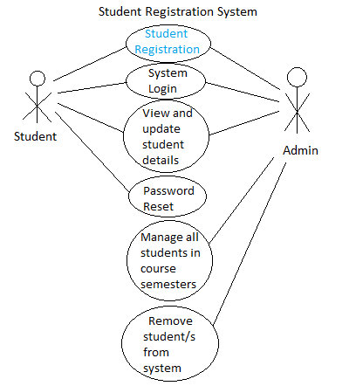

Figure - System Environment use case

The Student Registration System has two active actors and one cooperating system.

The student can register to a course for a particular semester, view and update his/her information through this system. The admin can view all students enrolled in a particular course of the University for the particular semester, add or remove and student/s, search any student and view and update his/her details. There is a link to the (existing) Courses table in the database.

## Product Functions

Context diagram –

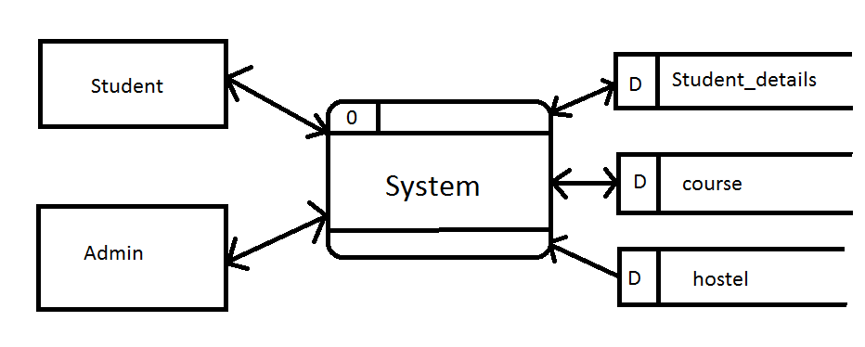



## Operating Environment

The application should run on any machine with Windows OS.

## Design and Implementation Constraints

It is required to implement this web application on Php and mysql database along with an appealing user interface and should be cross browser compatible

# External Interface Requirements

## User Interfaces

The GUI interface below will each give an idea of the requirements on each interface of the user and messages to display

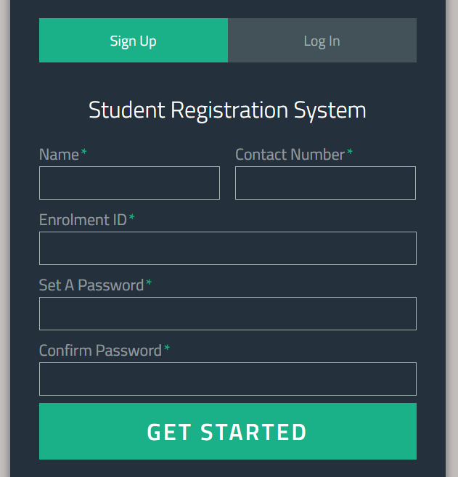

An interface for signing up into the system for a student. This should be the home page. It should take inputs as shown in the figure

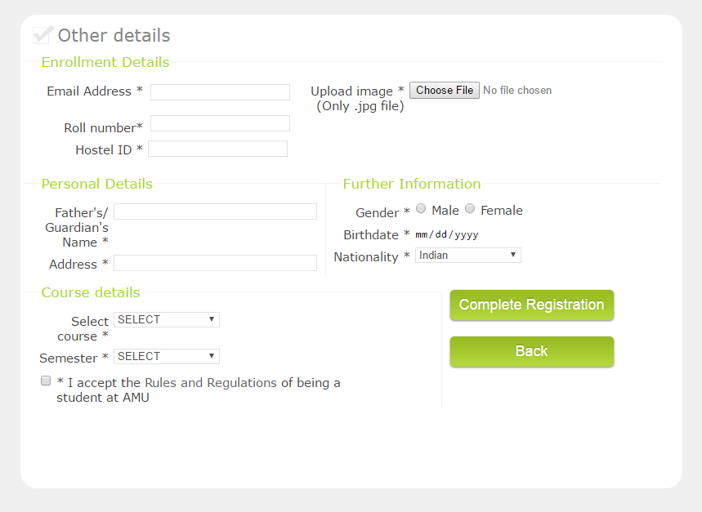

A next interface to complete registering other details and registering in a sem of a course.

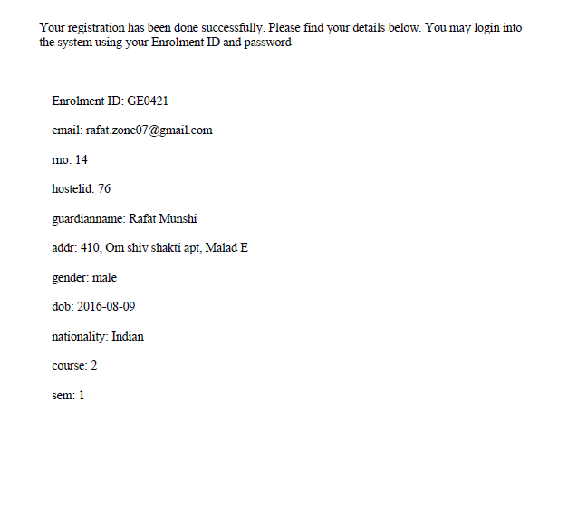

After successfully completing registration, the system should open up a pdf with confirmation message and other details like shown in the figure.

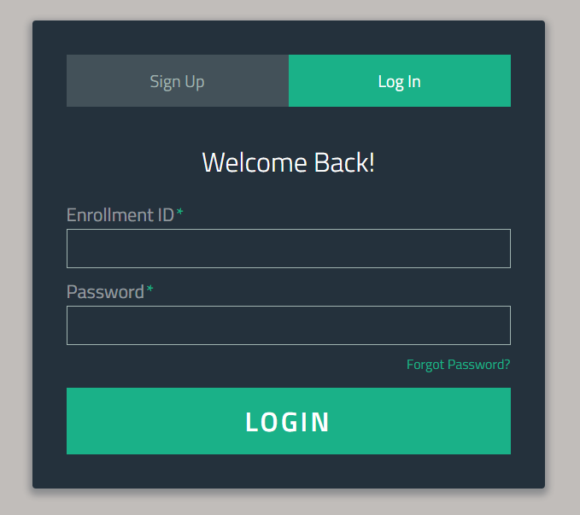

An interface for logging into the system for registered students using enrolment id and password

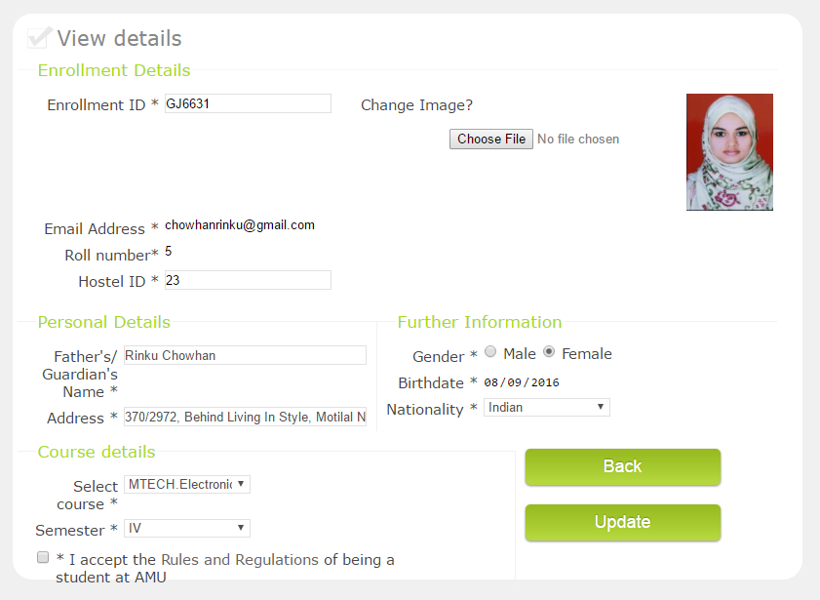

After logging into the system, the student should be able to view his/her details and be able to edit the information.

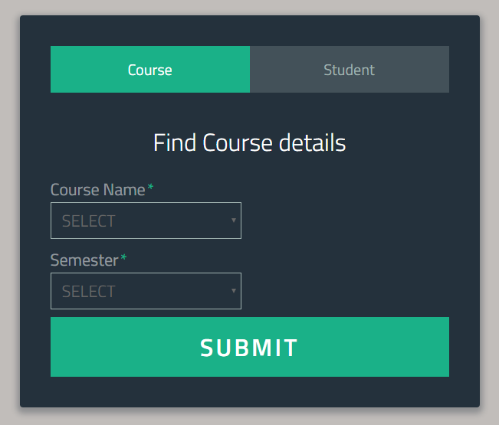

This is the page for the admin. The admin should be able to view all the enrolled students in a particular course for the particular semester.

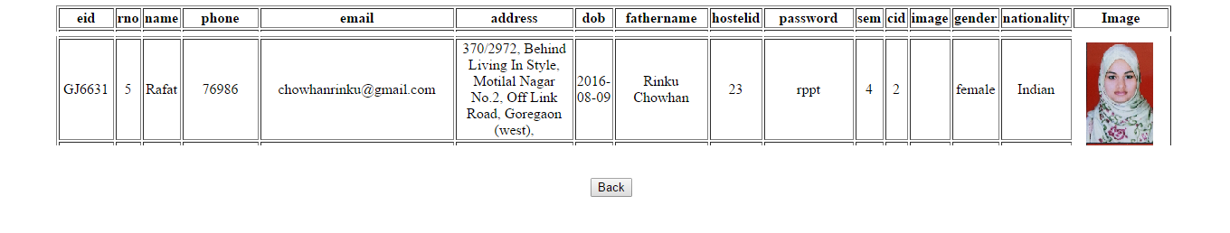

The result can be shown in this way.

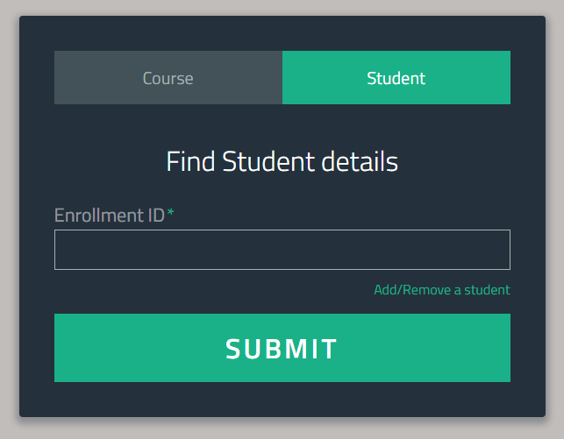

The interface for the admin to search and view details of a particular student. After this the admin should be able to similarly be able to edit the student’s details.

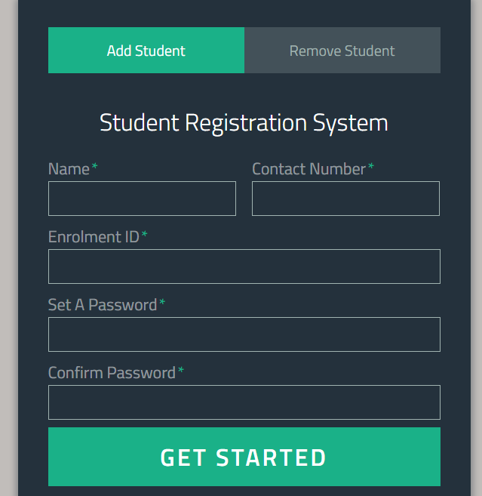

An interface is to be provided to the admin to register a student similarly.

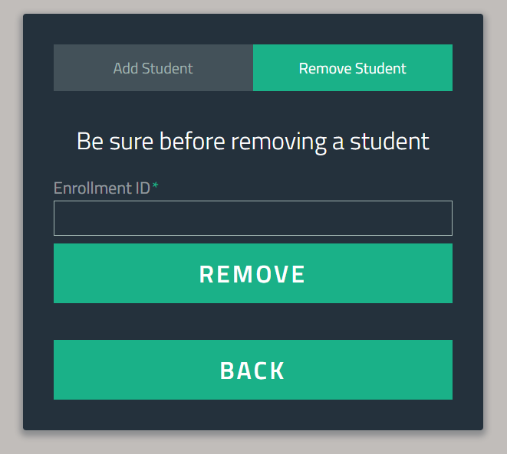

Admin should also be able to delete a student from the system in case of fraudulent or mistaken registrations/sign ups.

## 3.2 Hardware Interfaces

No hardware interfaces required.

## Software Interfaces

Only external interface should be the student database with all student’s, courses’ and hostel details.

# System Features

The application should be accessible to any user in the network from any machine.

## Functional Requirements Specification

This section outlines the use cases for each of the active user separately.

### Student Use Case

#### Use case: Student Registration

**Diagram:**

Student

Student Registration

**Initial Step-By-Step Description**

1. Student able to register all the details as shown in the GUIs.
2. Check for enrolment id if not already registered, only then register this student else alert the user to login with the enrolment id and registered password or check the enrolment id.
3. Check for availability in the course and semester. If already reached the maximum limit then alert user that registrations in the semester is over, and to kindly check the course and semester while registering.
4. A student should not be able to register in more than one course and is needed to be registered in atleast one course of the university.
5. If the check is pass, successfully register the student and generate and display a pdf for the user as shown in the GUI above.

#### Use case: System Login

**Diagram:**

Student

System Login

**Initial Step-By-Step Description**

1. Student should be able to login using enrolment id and password.
2. System should check the enrolment id and password with the database and direct to viewing details page on successful login
3. An error alert should be presented in case the id and password are incorrect

#### Use case: System login

**Diagram:**

Admin

System Login

**Initial Step-By-Step Description**

1. The admin should be able to login with common username and password i.e id= 0000 and password should be “amu_reg”
2. With this username and password, the admin can get to the admin page as shown in the GUI.

## User Characteristics

The student is expected to already have knowledge of his/her details of enrolment in the university course and be ready with the soft copy of his/her image in jpg format.

The admin is expected to have knowledge of database administration as well as the rules and regulations of enrolment in the university.

## Forgot password feature

4.1.1 Description

The student should be able to reset his/her password by verifying his/her details of email and date of birth followed by a success message of password reset.

# Other Nonfunctional Requirements

### Logical Structure of the Data

The logical structure of the data of the actors of Student Registration database is given below.

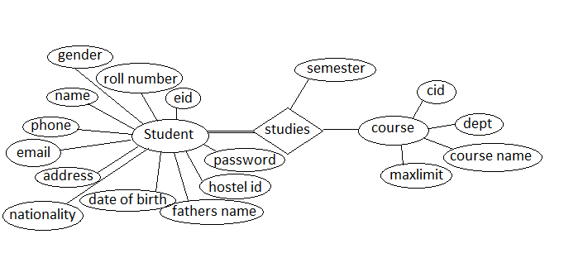



Figure - Logical Structure of the Student Registration System

**Student details**

|  |  |  |  |
| --- | --- | --- | --- |
| **Data Item** | **Type** | **Description** | **Comment** |
| Name | Text | Name of the student | Atleast 7 characters long |
| EID | Text | Enrolment ID | 6-7 characters long |
| Roll number | Number |  |  |
| Gender | Option | Male or female |  |
| Phone | Number |  | 10-15 length. |
| email | Email |  | @ present |
| address | Text |  |  |
| nationality | Option | Indian or NRI |  |
| Date of birth | Date |  |  |
| Fathers name | Text |  |  |
| Hostel id | Text |  |  |
| password | Text |  | Atleast 8 characters long |
| semester | Number |  |  |
| cid | Text |  | Course id |
| dept | Text |  |  |
| Course name | Text |  |  |
| Max limit | Number |  |  |